2023 Application Guide
This guide is your application cornerstone. Refer back to it regularly when crafting your submission.
CONTENTS
MAKING AN APPLICATION | PAGE 2
SUPPORTING DOCUMENTS | PAGE 5
CRITERIA FOR INCLUSION | PAGE 11
ACCESSIBILTY | PAGE 14
CURATORIAL CALL OUT | PAGE 15
ART FORM INFORMATION | PAGE 16
INTERNATIONAL APPLICATIONS | PAGE 24
CURATION & SELECTION PROCESS | PAGE 25
PLANNING WITH COVID-19 | PAGE 28
VENUES | PAGE 29
FUNDING | PAGE 36
PROGRAMMING DECISIONS | PAGE 42
THE FINANCIAL DEAL | PAGE 42
FESTIVAL SUPPORTS | PAGE 47
MARKETING & PR | PAGE 49
VOLUNTEERS +WILLING WORKERS | PAGE 51

MAKING AN APPLICATION
Dublin Fringe Festival, unlike many Fringes internationally, is a wholly curated festival. We seek compelling and daring work that invigorates, excites and challenges our audiences. Each year, we open a call for applications which receives hundreds of responses.
SO, HOW DO I MAKE AN APPLICATION TO PUT SOMETHING ON AS PART OF DUBLIN FRINGE FESTIVAL?
- Have a great idea.
- Read our 2023 application guide (yes, this one!)
- Submit an application through our online form link available here
- Prepare and include all supporting documents in your application.
- Do it all before 5pm GMT on Thursday, 2nd March. If you are applying to make work in your own venue (see venue section below) you must submit your application by 5pm GMT on Thursday 23rd February.

TWO VERY IMPORTANT THINGS TO KEEP IN MIND:
- Give us as much relevant information as possible.
- Be adventurous with your application and thorough with the details. We’re looking for solid artistic ideas and exciting concepts.

WHEN ARE APPLICATIONS OPEN AND WHAT’S THE DEADLINE?
Applications for the festival open on Tuesday 24th January and close on Thursday, 2 March at 5pm GMT. If you are applying to make work in your own venue (see venue section below) you must submit your application by 5pm GMT on Thursday 23rd February. This earlier deadline is to ensure that there is time for artists to secure their spaces given the current landscape of the city.
Supporting documents must be received by the same deadline. Late applications will not be accepted. You can submit your application online at any time between the opening of the online applications until the closing date.
PRE- APPLICATION WORKSHOP
We will host a pre-application workshop and Q&A on Tuesday 7th February at 6pm in Dublin Fringe HQ, to answer all of your questions about the festival, how to apply, what we're looking for and anything else we or you can think of. Please RSVP to Niamh at niamh@fringefest.com
CAN I TALK TO YOU ABOUT MY IDEAS FIRST?
Yes please! We have a year-round open door policy to discuss your ideas. Email us and we can organise a meeting or phone call with the Artistic Team, Artistic Director Ruth McGowan, Artistic Projects Manager Bee Sparks and Artistic & FRINGE LAB Assistant Niamh Murtagh. We have a lot of requests for meetings so please make sure to be in touch with us sooner rather than later. We generally meet with artists in 30 – 45 minute blocks to find out about your ideas and answer questions. Read the materials beforehand and come with your artistic and logistical questions prepared. The closer we get to the application deadline, the less available time we have so get in touch asap. You can contact us at programming@fringefest.com.
APPLICATION FORM
You can access our new and improved 2023 application form at the link available here. You are able to save drafts of it as you work through, so don’t worry if it takes you a couple of sessions. We advise you to get your application in early – don’t wait until the last day to submit! In the two days running up to the deadline there is often a strain on our server due to the high level of traffic, and meaning that some people have problems getting the application submitted on time.
Save yourself the stress & get it in early!
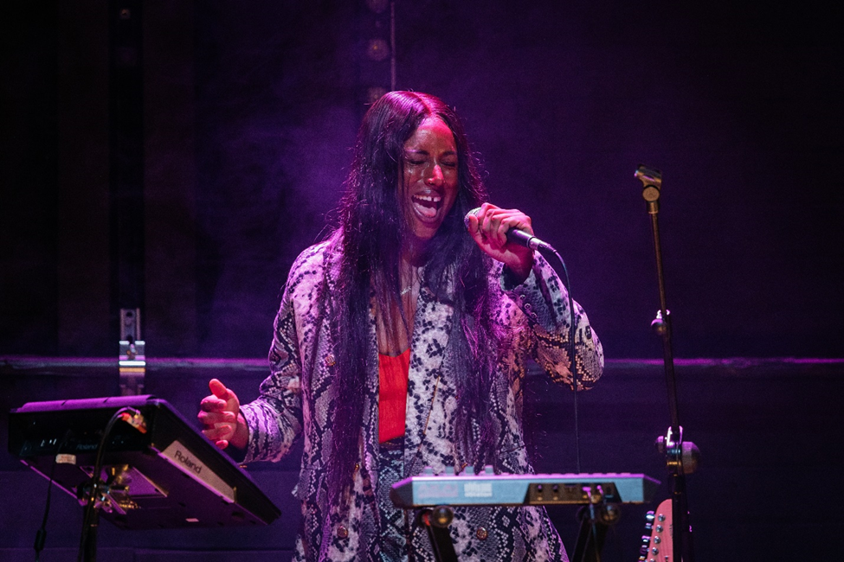
Fehdah, Dublin Fringe Festival 2021. Photo: Simon Lazewski

SUPPORTING DOCUMENTS
WHAT ARE THE SUPPORTING DOCUMENTS AND WHAT ARE THEY FOR?
When filling out the online application form, you’ll need to upload your supporting documents. Supporting documents should give us a clear sense of your ideas, your previous work and/or documentation of the existing show or work.
FOR NEW WORK
For work that is not yet made, but will be for September 2023 we expect to receive the following:
ESSENTIAL
- WHO: Biographies for all artists.
- HOW: A draft budget showing both income and expenditure (We ask to see this to understand the scale of the event you propose)
- WHAT: Script or link to video of rehearsal or storyboard or a one-page description of what happens in the show (It’s okay for these to be in draft stage, we understand the ideas are new).
DESIRABLE
Please send us some of the following, with a max of five files:
- Outline of design ideas
- Video link to a staged reading or rehearsal (we appreciate it when you include time signatures from which to watch). This can be taking place in an online format.
- Links to online videos of previous work and / or work in progress (we appreciate it when you include time signatures from which to watch)
- Images of previous work or work in progress
- Any other relevant information.

FOR TOURING WORK
(work that has already played outside of Dublin) the following are essential:
- Production images
- Links to online video (we appreciate it when you include time signatures from which to watch)
- Publicity images and/or examples of previous publicity material
- Technical rider
- Scale drawings of set
- Lighting plan & technical specifications
- Outline of tech crew you need
- Outline of your plan for set/ equipment transportation & any access issues
- Dressing room/ backstage requirements
- Risk assessment
- Company safety statement
- Any other relevant information

DO I REALLY NEED TO INCLUDE THEM?
Yes. Supporting documents are VITAL. It’s impossible for us to assess an application without them. Without supporting documents your application is incomplete and will be assessed as such.

WHAT KIND OF BUDGET DO YOU NEED TO SEE?
We need to see that you are seriously thinking about the costs that putting on your event will incur. Make sure you include both income AND expenditure. You can access a sample production budget that you can use to create a template through this link here.

HOW DO I UPLOAD MY SUPPORTING DOCUMENTS?
You can upload each of your supporting documents through your application form. Please name each file: as title of show, title of company/ artist name and title of file (i.e. Fleabag, Phoebe Waller Bridge, Script). The maximum file size is 1GB per item uploaded and the maximum amount of documents recommended is 25, you can upload zip folders if you’d like. If you have any trouble please don’t hesitate to reach out to niamh@fringefest.com
If you are sharing videos, consider uploading them to Vimeo or Youtube (can be set to private) and include the direct link, and password if necessary, in one of the documents you are sending. It will save you time!

HOW DO I KNOW YOU GOT MY APPLICATION AND SUPPORTING DOCUMENTS?
When you submit your application, the website will show you a page that says “Thank you! Your submission have been received”. You will then receive an email that includes a copy of your application for your records. You will receive this email automatically from noreply@jotform.com. Each of your supporting documents will be listed beside its relevant field.
If you are submitting more than one application, make sure you get the confirmation email each time. If you do not receive an email from JotForm after your submission (and you have checked all your spam and junk folders) or you are worried for any reason that your application may not have got through, you can contact niamh@fringefest.com to double check.

ACCESSIBLE VERSIONS
We have compiled accessible versions of all our application documents which can can accessed through the link here. If you need any guidance or assistance in this area please do not hesitate to contact us at niamh@fringefest.com

CAN I POST MY APPLICATION TO YOU?
No, we cannot accept postal applications. You must make the application online within the dates above.
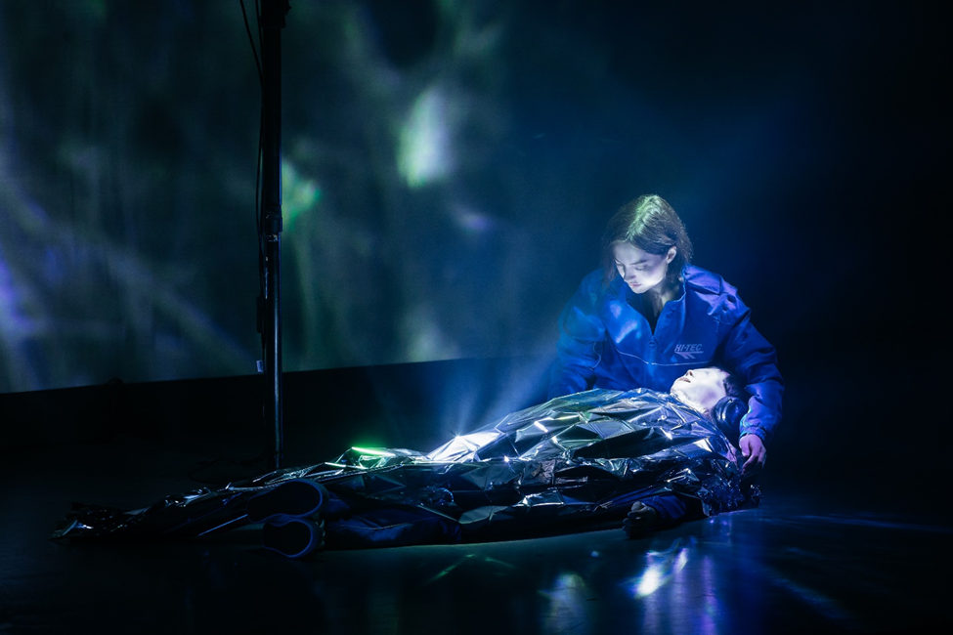Rescue Annie by Lauren Shannon Jones & Eoghan Carrick, Dublin Fringe Festival 2021. Photo: Simon Lazewski

CRITERIA FOR INCLUSION
WHAT KIND OF WORK DOES DUBLIN FRINGE FESTIVAL PROGRAMME?
Dublin Fringe Festival is made of the most exciting new Irish and international dance, comedy, theatre, music, circus, club nights, performance art, digital art, visual art, spectacle, storytelling, fashion, spoken word and cabaret.
We are dedicated to new work and providing a platform for new ideas and artists to thrive. We look for experimentation, authenticity, vision and craft. We like hybridity as much as we like a singularity of purpose. We champion interdisciplinarity and support projects and approaches that otherwise might fall through the cracks. We encourage new artists, new voices and artists working professionally in one genre that want to try something new.
We are engaged with the city, the country, our audiences and the times in which we live. We look for ideas that are experiential, in strange places, cross-disciplinary, unusual, enormous, tiny, outdoors, DIY, risk taking, challenging and exemplify an independent spirit.
Dublin Fringe Festival is a curated festival. We love working in partnership and we welcome applications from individuals, organisations and groups to host special Fringe editions of existing events and happenings.
Yours is the lead we want to follow. Show us the way with:
- Radical and unapologetic work. Risk it. Your most fierce, most courageous projects can find a home at Fringe.
- A focus on the now and the next. We’re a festival of firsts supporting new thought, innovative practice and fresh ideas. No cover versions, please.
- Form-busting, genre-defying, game-changing approaches to art-making. Make something that’s never been seen before.
- Rigour. We value your expertise, and your craft gets our pulses racing. Less clickbait, more long read - put your skills on show.
- Voices that defy the mainstream. Make the work you’ve been longing to see. Take the mic; you’re the one we’ve been waiting for.

Make sure you read the curatorial information below carefully as it contains information that will be useful for you in deciding whether your work is a good fit for this year’s festival.
Dublin Fringe Festival are committed to creating a diverse programme of work and we welcome applications from artists of all gender identities, nationalities, races, cultural backgrounds, ages, religions, languages, different abilities, sexual orientations, socioeconomic statuses or geographic regions. If you would like to speak with us about any barriers to access you may be facing, please do so and we will work to remove them. We can offer some supports within a limited budget. You can contact bee@fringefest.com to discuss.

ACCESSIBILITY
We work hard at Fringe for the festival to be as widely accessible as possible, for cast, crew and audience. We are asking all our applicants to consider the accessibility needs of their team.
We aim to facilitate accessibility needs throughout the process and, together with our venue partners, once you are in your venue. In your planning, we ask you to consider how accessible your rehearsal space and your rehearsal materials are. Care doesn’t compromise the integrity of your work. It enhances the engagement of your team and your audiences.
We have compiled accessible versions of all our application documents which can can accessed through the link here. If you need any guidance or assistance in this area please do not hesitate to contact us on niamh@fringefest.com
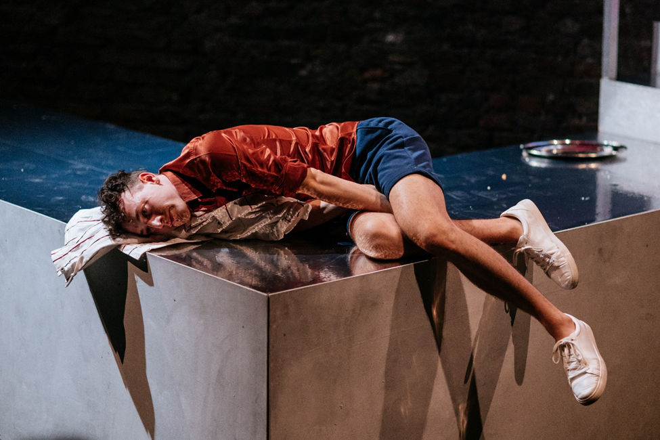
Narcissus by Taste in Your Mouth, Dublin Fringe Festival 2021. Photo: Simon Lazewski

CURATORIAL CALL OUT
CURATORIAL CALL OUT 2023: City Limitless
We’re imagining a map. Fine print on a well-worn page – Dublin now and Dublin then – and in our palm, a pencil. There’s a future to be drawn. There’s a festival to be made.
Sketch with us. Trace the city’s layers. Energy pings through finely drawn lines, ravenous, and ready to be released. Scrawl collectivism, beauty, care, joy. Be expansive in your approach. This map has space for everyone, there is enough land and sky to share.
Let’s reroute the river, queer the monuments and rewire the power sources. This is Dublin Fringe Festival we’re talking about: don’t stay within the lines. Use every crayon in the box. Draw playgrounds in the place of office-blocks, scribble laughs along electricity cables, mark chaos between the cobblestones and ink mischief across the grid. Together we’ll redraw the city as we want it.
Maps make sense of where we are now, and show us where we could go next. Artists, you are the key. To the map, to the city, to the possible. Chart the topography of your craft. Lace your dreams around the lines of latitude. Allow hope to sink in. All the art you have yet to make. All the dormant ideas yet to erupt, transforming the landscape, making it new.
Drop a pin. Situate yourself in time and place. Your body is your first landscape. Inhabit it. Sound travels - let your ideas echo. Whisper poems through the airwaves, pulse beats into old walls, hammer your feet on the streets until they know the rhythm of us. Seed bomb the concrete with colour. Fill glass and steel spaces with living, breathing art.
Find potency in vacancy - it makes room to experiment. The worlds you create to share shed new light, upturn tradition and remind us to laugh at notions of permanence. Your art poses questions, pokes fun, unsettles, sends tired systems tumbling like Jenga. Towers turned back to blocks. Blocks that could build new things.
This is an all-island call to action for disrupters, visionaries and messers to show your boldest ideas to intrepid audiences. We count on your guts, graft and glitter. Gather a crowd and invite them to see differently. Cast a spell of stillness with unexpected beauty in a familiar place. Unfurl new potential through a performance beyond words. Capture the anticipation of late night lights through wet bus windows. Provide the certainty of found families tethered across a dance floor.
Before you know it, you’re running lines in the bike lane, cracking the redraft on the red line, practicing muted choreography while waiting for the 46A. Eureka moments hummed into voice notes, epiphanies that turn your walk home into a run. The shared momentum all adds up and when you look around, the city is as you drew it for a brilliant moment in time.
This September, let’s render the city limitless.
- Ruth McGowan, Artistic Director & CEO and Bee Sparks, Artistic Projects Manager

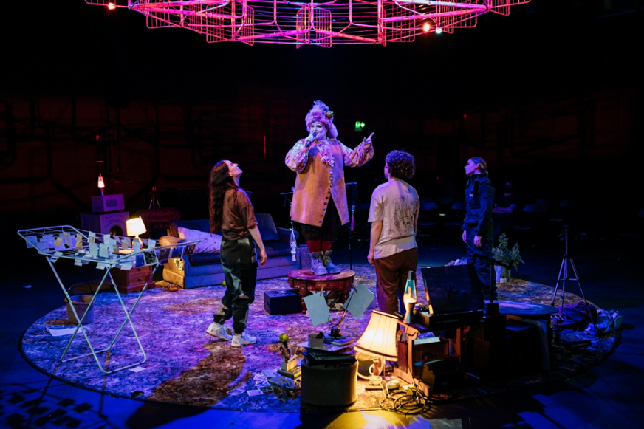
Where Sat The Lovers by Malaprop, Dublin Fringe Festival 2021. Photo: Simon Lazewski

ART FORM INFORMATION
CABARET
WE ALL WANT TO SING ALONG!
We’re looking for daring, contemporary cabaret proposals. The decadent, the queer, the beautiful and the gas - let us know what you’ve got cooking! We are open to fabulous once-off events or runs in a Fringe venue.

CIRCUS | DANCE | PHYSICAL THEATRE
WOW YOU CAN REALLY DANCE
We back artistic risk and works of skill and virtuosity, made with intellect and detail. We are interested in new material that is cross-disciplinary, experimental, with original design concept. We welcome projects in unusual setting, adding an element of surprise and delight to the audience experience. We want to bring the festival magic to accidental spectators too, so we’re open to proposals for street performance.

CLUB NIGHTS
CLUB CULTURE IS CULTURE
We hold transformative dancefloor experiences as sacred and we appreciate the value of a life-saving DJ set. We’re taking submissions from party impresarios, promoters, DJs, performance artists and buzzers to create special edition club nights and art experiences in the spirit of the sesh. .

COMEDY
WE’RE NOT JOKING!
Fringe is home to Ireland’s biggest stars and its biggest stars-to-be. Bring us your new idea for a show for one of Dublin’s classic clubs or test out new formats. We’ve presented all kinds of comedy in all kinds of media: talk shows, wellness classes, theatre, spoken word, digital, the list is pretty endless. We are fans of helping make outside of the box projects happen. We look for ambition, skill and something outside of the usual. Pitch us proposals where Fringe can help you take your next step.
SPOKEN WORD
SPEAKING THE CITY
We want your verses! We’re looking for experimental, genre-pushing spoken word, for new voices, new narratives and new ways of thinking about performing poetry. If you have a story you need to tell, a collection that you’re ready to pair with live elements or want to take the audience on a journey through the city streets then let us know!

MUSIC
SOUNDTRACK TO OUR SEPTEMBER
We welcome online applications from musicians, bands, artists or promoters planning to make work or events that are new, experimental, experiential, cross-disciplinary, risk-taking and engaged with society. We are particularly looking for concerts, happenings, shows and events that use performance elements not seen in a usual gig, although we’re happy to host a great straight-up music show too. If you’re a promoter or a musician who wants to meet us directly to talk about your proposal before undertaking the application process, just drop us a line.

THEATRE
MAKING A SHOW OF OURSELVES
We programme theatre projects that take risks, experiment with form and defy categorisation. We’ve presented theatre fused with live art, film, music, gig, dance, game, installation, the list keeps growing. Thematically, we are interested in ideas that engage with the context of this city, society and current politics, and that interrogate ways Dublin and Ireland connects with the rest of the world. When considering new writing, we look for singular voices and ideas, formal innovation and thematic resonance. We focus on new work and new ideas, and we do not programme adaptations or work based on canonical and previously performed texts, unless there is a dedication to innovation and an inventive, radical re-thinking of the work.

VISUAL ART
WE WANT TO BE SWEPT AWAY
The kind of work we are interested in programming is cross-disciplinary, experiential, risk-taking. Visual artists working on concepts and projects where viewership, spectatorship or an audience is a key part of the concept of the work are of particular interest to us. We have presented artists’ work in the areas of performance art & live art, photography, film, installation and work drawing on community-based practice.

YOUNG AUDIENCES
FOR AUDIENCES ON THE RIGHT SIDE OF ADULTHOOD
Young Radicals is our programming strand presenting brilliant work made for and by children and teens. If you are an artist of any discipline interested in creating exciting performance experiences for under 18s, we want to hear from you. Same rules apply as for the rest of the festival – we want radical, rigorous work that is new to Dublin and artistically inventive.

REMOTE ART EXPERIENCES
BE AT THE VANGUARD OF AN EVOLVING ART FORM
Remote art experiences can meet audiences where they’re at through a variety of means – we want to hear your innovative ideas. The internet isn’t the only way to reach people at home: we welcome proposals for radio projects, audio walks, projects made for the post, plays by text message, gigs over the phone and intimate door-to-door performances. We love tactile and embodied experiences, that take us somewhere (without taking us anywhere!)

When it comes to digital art experiences, we are interested in projects that create a real-time connection between audience and artist, crafting shared experiences and facilitating active spectatorship. This includes interactive, live and born-digital works, made bespoke for online platforms. We do not programme live streams of traditional performances or short films.

We are looking for proposals where the form is integral to the idea, not simply a plan B.
TAKEOVERS
THE SPACE IS MINE
We back innovative collectives, interdisciplinary experiments and emerging curators! If you want to take over a space with an installation or mini-programme then let us know. Dublin Fringe can provide a supportive launch pad for collectives, organisations, happenings and programmes that are ready to nail their colours to the mast!

I’M JUST TOO RADICAL
YOUR FORM IS BUSTED
Some of the questions on the form may not necessarily be relevant to you or your project and if this is the case we ask you to be patient and include your information as best you can.

If it is impossible for you to communicate your idea through our application form, please don't give up. We would still love to hear from you. Please email niamh@fringefest.com to set up a time to come in to have a chat with our Artistic Team about what your idea is.

We meet people all the time with ideas of all sorts – zines, publishing, web projects, happenings, pop-up cafés, durational performances, and more. So please do get in touch!

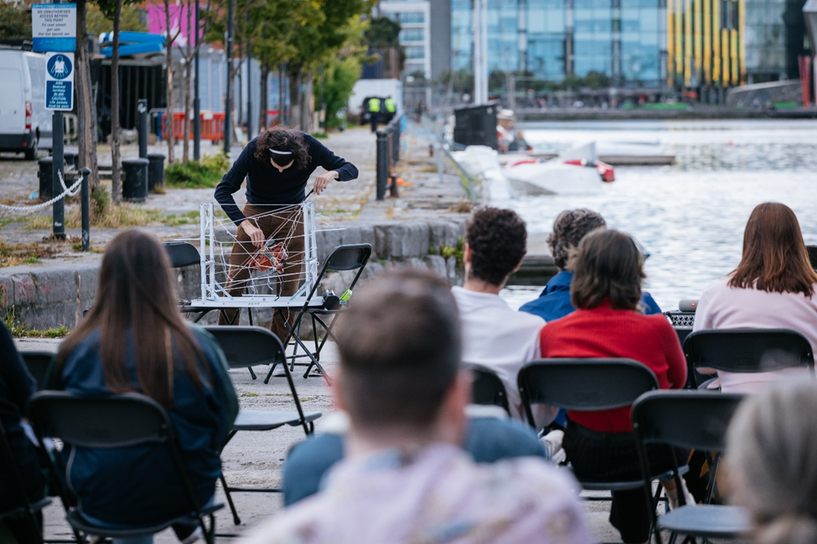
Music for Cranes by Kirkos, Dublin Fringe Festival 2021. Photo: Simon Lazewski

INTERNATIONAL APPLICATIONS
DOES DUBLIN FRINGE FESTIVAL PROGRAMME INTERNATIONAL WORK?
Each year we programme a small selection of international work that fits the festival’s curatorial vision (see Criteria for Inclusion section above). We love hosting international artists at the festival and sharing in the new perspectives and experiences their work offers to Dublin audiences. This work is programmed in two ways –
- Where international work has been seen by the Festival Director personally and a company is invited to participate. Applications for invitations are not accepted.
- International companies and artists can make an application through our online system and may be programmed into the festival based on the strength and suitability of the work as judged from their application. Please note: you will need to plan to cover your own travel costs as part of your budget.

CURATION & SELECTION PROCESS
WE ASSESS APPLICATIONS WITH THE FOLLOWING CRITERIA IN MIND:
- We focus on programming new work and new ideas, projects that take risks and experiment with form.
- We are interested in themes and ideas that engage with the context of our city and society, and that imagine ways Dublin and Ireland can connect with the rest of the world.
- We carefully consider the originality and quality of each proposal.
- We carefully consider the potential or track record of each artist/ company.
- In the case of shows that are already touring, we prioritise work that has not been previously seen by Dublin audiences. In the case of digital work we will prioritise projects that will be the Irish premiere.
- In the case of submissions from artists and companies based outside of Ireland, we look for work that will fit the Irish context. In general, we are most interested in presenting work whose style or content is not already available to Dublin audiences.
- We consider the practical viability of each application, in terms of how developed ideas are, whether the project is realistically achievable on the indicated budget, and on the basis of venue availability.
- Please note that shows are considered and selected giving consideration to the programme as a curated whole.

WHAT KIND OF WORK DOES DUBLIN FRINGE FESTIVAL NOT PROGRAMME?
In general (although we may make some exceptions as we are rule breakers by nature) Dublin Fringe Festival does not programme:
- Work that has already been seen by a Dublin audience in its proposed form.
- Adaptations/ cover versions or traditional re-tellings of pre-existing texts or compositions.
- We do not programme live streams of traditional performances or short films. Please read our Remote Art Experiences section for details about our curatorial interests.

We love talking art. If you would like to ask us about the suitability of specific ideas before you make an application, do get in touch. As early as possible!
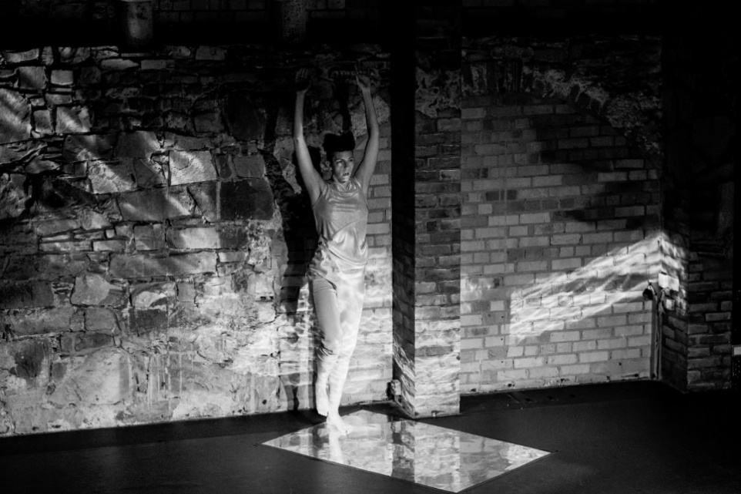
Glisten by Isabella Oberlander, Dublin Fringe Festival 2021. Photo: Simon Lazewski

PLANNING WITH COVID-19
COVID continues to be a factor in planning for live performances. From experience, having delivered a festivals in 2020, 2021 and 2022, we’ve learnt that it’s crucial to stay nimble and plan with agility.

All applicants should:
- Assume COVID will still be a factor in September 2023. Make plans that consider COVID safety as part of your working practice for both rehearsals and presentation. Here are some excellent industry standard guides to familiarise yourself with:
- Theatre Forum’s guidelines for 1) Safe Creation and Staging of Work and 2) A Framework for Performing Arts Venues.
- The Department of Enterprise, Trade and Employment’s Work Safely Protocol.
- Make plans and budgets based on utilising a maximum of 50% of your venue capacity. This will allow you to plan with resilience as the times change.
- Don’t worry, help will be at hand! The Dublin Fringe team is here to help you get to grips with making work safely. We’ve done this before, so if you have a question we may have figured out the answer during a previous festival.

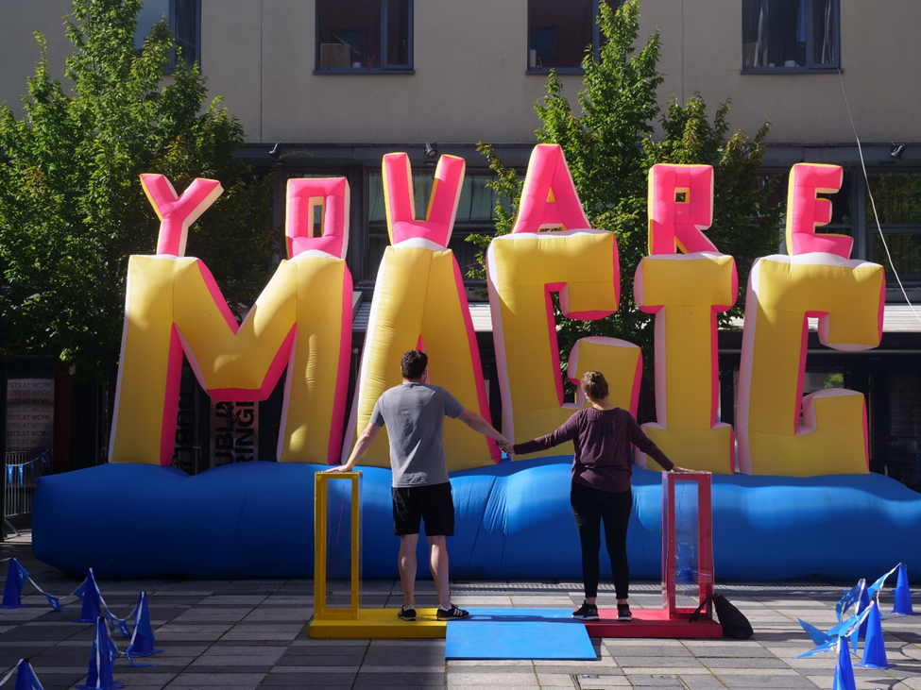
You Are Magic, Alicia Eggert, Dublin Fringe Festival 2021. Photo: Simon Lazewski

VENUES
DO I HAVE TO FIND A VENUE FOR MY EVENT?
To be part of Dublin Fringe Festival, you must either:
- Apply for a Dublin Fringe Festival venue slot
- Apply with your own venue
- Apply with a project taking place remotely, for which you don’t need a physical venue
It’s very important for you to think about what kind of space your work needs and what the ideal audience size / relationship is etc.
PLEASE NOTE: Please read the Financial Deal section below carefully to understand the impact your venue choice has on the financial deal.

DUBLIN FRINGE FESTIVAL VENUE SLOT:
If you are applying for a Dublin Fringe Festival venue slot, you must consult our venue specifications and list your venue preferences in your application. Our venue specs are available to view here.

If your work is programmed, you’re not guaranteed to get the slot you request, but it really helps to show what these slots might look like so you can clarify the space, run length etc. that you would like when we’re putting together the matrix of the festival programme.

The festival deals directly with all these venues, and it is important to note that Fringe venue slots are often in shared venues (so you will have other shows using the space before/ after you). This will of course align with the current (at the time of performing) HSE guidelines with regards to the sharing and use of space. Dublin Fringe Festival covers the full cost of venue rental and this is reflected in the financial deal for those programmed into a Fringe venue slot (see THE FINANCIAL DEAL section below). Duration for Fringe shows tends to be approximately 60 minutes, so keep that in mind when considering venue – if you would like a show with a significantly longer or shorter duration please flag at the point of application.

Please note, that Fringe venues are competitive. Do think broadly about where your event can take place and outline at least a couple of options in your application.

YOUR OWN VENUE:
If you are applying to make work in your own venue you must submit your application by 5pm GMT on Thursday 23rd February. This earlier deadline is to ensure that there is time for artists to secure their spaces given the current landscape of the city.
Some people come to us with venues in mind that they have already sourced or are planning to source. These tend to be site-specific and/ or unusual venues, or sometimes work simply cannot work in our shared venue schedule. If you are planning to make the work site-specifically or in your own venue it is generally assumed that you will source the venue yourself, though we often give advice and guidance on this. In the instance of you coming to the festival with your own venue or location, you will cover your own venue rental and this will be reflected in the financial deal (again, see section below). If you are looking at various possibilities or types of spaces contact us directly if you would like a list of some alternative or offsite venues which have been used in the past or are on our radar if helpful.

WHAT IF I WANT TO DO SOMETHING IN A SITE-SPECIFIC PLACE, LIKE A CAFÉ OR MY HOUSE OR IN THE STREET?
Anything is possible at Fringe! Let us know what you want to do and why. Make sure it’s clear in your application that you have thought through at least some of the practicalities of that particular space (Is the owner of the cafe really willing to close some or all of the space for you? How do you get the audience to your house? Do you need access to electricity? Do you need a strong wifi connection? Will you need to think about security, and the costs that entails?). Also, make sure it’s clear WHY you are choosing that space – is it really an integral part of your idea, or is it a gimmick? You’ll need to secure all relevant permissions to use the space for a public event. If you receive an invitation the be part of Dublin Fringe’s programme, we’ll need to see a signed agreement with the venue within two weeks of that offer. This means you need to have begun conversation and gotten initial interest or permission before May 2023.

UNTAMED OFFSITES:
We love offsite work and we are experts at it. The Dublin Fringe production team can help you with lots of ideas and support you to make your show happen in the space you want. Be aware we have a limited supply of equipment available for shared use so the sooner you talk to us the better! Get in touch – we’ll talk about what’s possible. You can see a list of some options through this link here.
OUTDOOR VENUES:
It could be an outdoor stage with theatre set-up, a show with a walking tour format, a self-guided audio walk around a beloved neighbourhood – the options are endless. Working outdoors in Irish weather or in a city has all kinds of challenges, but Dublin Fringe’s production team are here to help with equipment and expertise to support you.
If you want to use an outdoor space, the Fringe team will be able to give you advice on what to do in the run up to the festival. Dublin Fringe Festival has to obtain permits and insurance for all the venues we use, so some unofficial spaces and squats are not possible for us.
MAKE SPACE FOR ART FUND
Dublin Fringe Festival has designated a fund of €5000 to support events made for unconventional performance spaces in Dublin. This can cover any associated venue/ site costs.
Artists responding to our open call with projects made for unusual, off-road and non-traditional performance sites can apply for financial support to help make their ideas a reality. We have introduced this fund in response to the changing city, and the new challenges and financial barriers to making art outside of traditional performance spaces in Dublin.

HOW DOES IT WORK?
Artists who submit projects that fit this brief to our open call for applications can opt to be considered for this financial support by outlining in their budget a breakdown of costs to a maximum of €3000. There is a total fund of €5000 available and it is intended that at least 2 projects can be supported.

An unconventional performance space means anywhere that isn’t purpose built for live performance. Theatres, cinemas and galleries are not eligible. Everywhere else is. In the past Fringe has presented shows on boats, up trees, and in parks, shopfronts, boxing rings, pubs, basement apartments, handball alleys and swimming pools.

Eligible costs associated with working in a non-traditional space are space rental, security costs, production equipment hire, employer liability insurance, fire safety costs, electricity generators, rain cover, and permit processing fees.

REMOTE ART EXPERIENCES:
We’re excited about bringing shows to audiences where they are: if you have any idea for a show that audiences can experience from/ near home let us know. The venue could be the audiences’ kitchen radio, their postbox, their phone, or their nearest patch of grass – the list is endless. We are determined that while these experiences may take place from a distance, closeness is key. We want to ensure audiences are captivated throughout – think about how to inspire active spectatorship from your audiences.

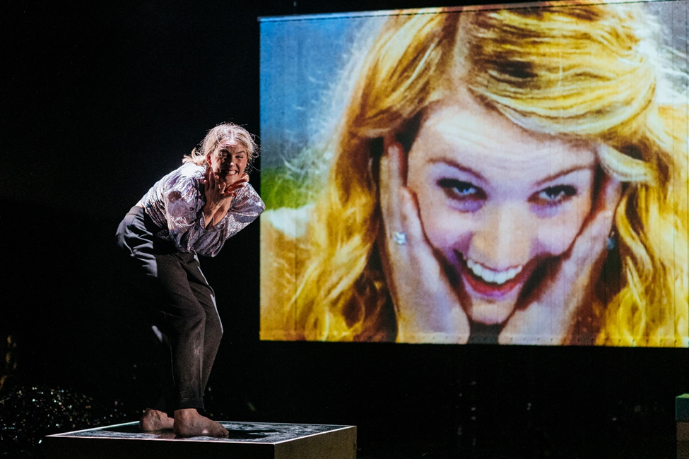
Minseach by Sibéal Davitt, Dublin Fringe Festival 2021. Photo: Simon Lazewski

FUNDING
(NOTE: If your event is selected to be part of the festival, you will be invited to attend numerous free workshops, including a workshop on producing. These workshops will go into all of the below areas in more detail. However, do think through these things before you make your application – having a budget outline as part of your supporting documents is essential to your application).

DO I NEED TO PAY A REGISTRATION FEE TO BE PART OF THE FESTIVAL?
No. We are delighted to say that we are one of the few Fringes world-wide who are in a position to waive the registration fee for events selected to be part of the festival.

WHAT ABOUT INSURANCE?
We cover the cost of Public Liability insurance, but you must look after the Employers Liability Insurance. Last year this cost was about €130 - €150. Please note that to be covered under our Public Liability insurance you must provide us with a risk assessment and safety statement, our Production team can advise you on this process.

CAN DUBLIN FRINGE PRODUCE MY EVENT?
No. In the majority of cases, companies who are programmed into the festival through our application system are self-funded and produce their own work. The festival is the presenter of the work and supports programmed artists via subsided venue rental, marketing, FRINGE LAB facilities, centralised box office and production assistance and a whole host of skill development workshops and seminars; however the direct costs of production are covered by the artists/companies.

DOES DUBLIN FRINGE FESTIVAL COMMISION WORK?
A small number of projects are invited to and/or commissioned by the Director to participate, and in these circumstances Dublin Fringe Festival supports the work to a greater extent. If you wish to speak to the Artistic Director about a potential commission, please email ruth@fringefest.com before February 9th

WHERE CAN I GET FUNDING?
First of all, make sure you’ve budgeted properly and know how much you need! You will probably need to look for funding from various sources, rather than planning to get one lump sum that will cover everything. Funding is available from the Arts Council of Ireland, and various local bodies such as your local city or county council. Visit their websites to find out what is available and how to apply – make note of the application deadlines. Depending on your project, there may be other organisations that you could approach for assistance – national cultural organisations such as the Goethe Institut, Instituto Cervantes, Alliance Française, Polish Embassy etc. Other arts and community organisations can also be brought onside as partners to help you. They may not be in a position to offer you money but might be able to help with support in kind or in exchange.
Presenting companies often crowdfund in the run up to their production through Fund It, or fundraise by hosting events (table quiz etc.), selling advertising space in their show programme or searching for company sponsorship. The fundraising campaigns need to conclude before tickets go on sale for your show. Think as laterally as possible!

WHAT COSTS WILL I BE FACING IF I’M PROGRAMMED?
Here are some of the costs that you may come across depending on the type and size of the event that you are planning:
- Fees & wages (director, actors, designers, crew, production manager, technicians, stage manager, etc.)
- Rehearsal space rental (there may be some time available at FRINGE LAB but no company will get a full rehearsal period)
- Venue rental if you are not in a Fringe venue (see Venues and The Financial Deal sections)
- Marketing costs (graphic design, photography, filming, posters, fliers, distribution etc.)
- Technical costs (design, sound, lighting, props, costumes, projector rental, archival video and pictures etc.)
- Travel & transport
- Accommodation
- Employer’s Liability Insurance – this covers you and the people you are working with
- Health and Safety or security expenses
Make sure you read the section below on THE FINANCIAL DEAL. You’ll be asked to indicate which of our financial models works best for your project in your application form, and your preferred financial deal option should be reflected in your budget, submitted with your supporting documents.
It will help your application to demonstrate that you have thought thoroughly about your budget outline. The following template available at this link here may be helpful when preparing your budget.
We will go into more detail about budgeting tips and advice during the Producing workshop available to programmed artists.
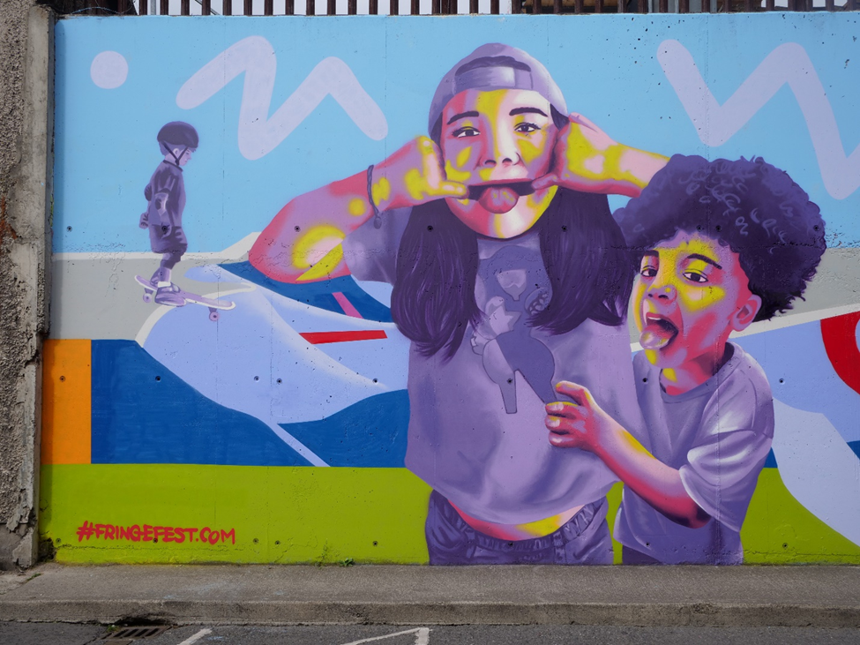
Dublin 8, You’re Lookin’ Great, Emmalene Blake, Dublin Fringe Festival 2021. Photo: Simon Lazewski

PROGRAMMING DECISIONS
WHEN WILL I KNOW IF MY WORK HAS BEEN PROGRAMMED?
We hope to communicate all programming decisions by early May 2023. We hope to communicate all programming decisions by early May 2023. It’s exciting times at Dublin Fringe Festival, as we are recruiting for a new Festival Director. This means we are planning with flexibility and our traditional timeline may change slightly. If that happens, you’ll be the first to know – all applicants will be updated by email if decision dates need to change.

All applicants will receive a notification by email. If you are programmed, let us know immediately if you have any changes to your availability or if the proposed event has changed in any way. Any change in duration is of vital importance when programmed in a shared venue.

CAN I APPEAL DECISIONS?
No – programming decisions are final. We can offer feedback on applications, although due to volume of applications this usually takes place after the Festival cycle has been completed.

THE FINANCIAL DEAL
IF I AM PROGRAMMED, WHAT FINANCIAL DEAL IS MADE WITH THE FESTIVAL?
By having your work programmed as part of Dublin Fringe Festival, you agree to a split of your box office income with the festival. There are two main types of box office split with the festival and this is determined by the following:
- If you are programmed in a Dublin Fringe Festival venue slot.
- If you are programmed with your own venue.
(For more information see the section on VENUES above)
You will be asked to indicate in your application form and attached budget the financial model that best suits your project.
TICKET PRICE
Dublin Fringe Festival decides on the ticket price for each event in consultation with the artist/ company. When budgeting at this point, it’s useful to look at previous ticket prices in similar venues/ types of work in past programmes to use as a guide. You can view them through this link here.

BOOKING FEE
Before the box office split takes place, a €2 booking fee comes off the top of each ticket. This booking fee goes directly to the festival and pays for the box office services the festival provides to every show.

HOW IT WORKS IF YOU’RE IN A DUBLIN FRINGE FESTIVAL VENUE SLOT:
If you are programmed in a Dublin Fringe Festival venue slot the box office split is 75:25 in your favour, so you will receive 75% of your box office income and Dublin Fringe Festival will receive 25% (minus booking fee). This 25% to Dublin Fringe Festival covers the subsidised venue rental. That means that your box office split is based on the ticket prices MINUS the €2 booking fee. For example: a €12 ticket minus €2 booking fee is €10, 75% of that is €7.50 which is your box office split. Fringe takes the remaining 25%.
- Dublin Fringe Festival covers the full cost of venue rental and the technical equipment that comes with that space (so you have no upfront venue rental cost, unless you have very particular technical requirements outside of what is usually provided).
- You are provided with a production schedule and a performance schedule from Dublin Fringe Festival.
- Dublin Fringe Festival provides house managers to supervise the turnarounds in the shared venue, but you must have your own production staff to actually do the turnaround and run your show.
- Dublin Fringe Festival team manages box office, advance audience information and front of house

HOW IT WORKS IF YOU’RE IN YOUR OWN VENUE:
PLEASE NOTE: This includes remote art experiences where the location/ site is manged and hosted by you (e.g. online platforms, in the post, on the radio etc).
If you are programmed with your own venue, the box office split is 90:10 in your favour, so you will receive 90% of your box office income and Dublin Fringe Festival will receive 10% (less booking fee).
That means that your box office split is based on the ticket prices MINUS the €2 booking fee. For example: a €12 ticket minus €2 booking fee is €10, 90% of that is €9 which is your box office split. Fringe takes the remaining 10%.
- You cover your own venue rental and most technical equipment required (we do have a small technical rider for offsite work so we may be able to provide some equipment). The rental/ hosting deal that you make with the venue is your own responsibility.
- You cover any security and personnel costs for this venue/ space.
- As the festival does not subsidise your venue rental and you cover these upfront costs, the festival only takes 10% of your box office receipts (so you receive a greater box office percentage)
- You propose your own performance/ event schedule and this is agreed with Dublin Fringe Festival
- You manage your own production schedule and all staffing (Dublin Fringe Festival can offer advice on these if required)
- Dublin Fringe Festival production team will visit your space and support and advise where possible and where required
- Dublin Fringe Festival team manages box office, advance audience information and front of house.

NEED ADDITIONAL FINANCIAL SUPPORT FROM DUBLIN FRINGE?
Some projects need more support in order to be realised – be it that Dublin Fringe Festival cover a key access cost, give greater technical support, cover an upfront cost in advance of your receiving your box office income etc. In a very small number of cases, Dublin Fringe can provide additional supports within a limited budget to remove barriers to creation for ambitious ideas.

Please outline in your application the scale of support you would need, to a maximum of €1200, and make sure the request is reflected in your application form and budget.

Please note: It is advisable to reach out and talk to the artistic team if you need additional financial support – contact Bee. Support is prioritised for projects that are impossible to achieve without this additional investment.

FESTIVAL SUPPORTS
ALL WORK PROGRAMMED IN THE FESTIVAL RECEIVES THE FOLLOWING (AMONGST OTHER THINGS) FROM DUBLIN FRINGE FESTIVAL:
- Ongoing advice and support in the run up to the festival from the festival staff
- A series of free skills-building workshops on producing, marketing & PR, health & safety, box office, directing, dramaturgical support and a technical workshop
- Online and centralised box office system
- Dedicated box office and front of house staff at every event
- Opportunities to avail of subsidised rehearsal space
- Production advice and assistance (though you still need to have your own technical team)
- Marketing and PR advice and assistance
- Inclusion in the printed brochure, festival website and in general festival marketing and PR campaigns and materials
- Access to our Willing Workers List for people to help on your event
- Access to the many facilities available at FRINGE LAB

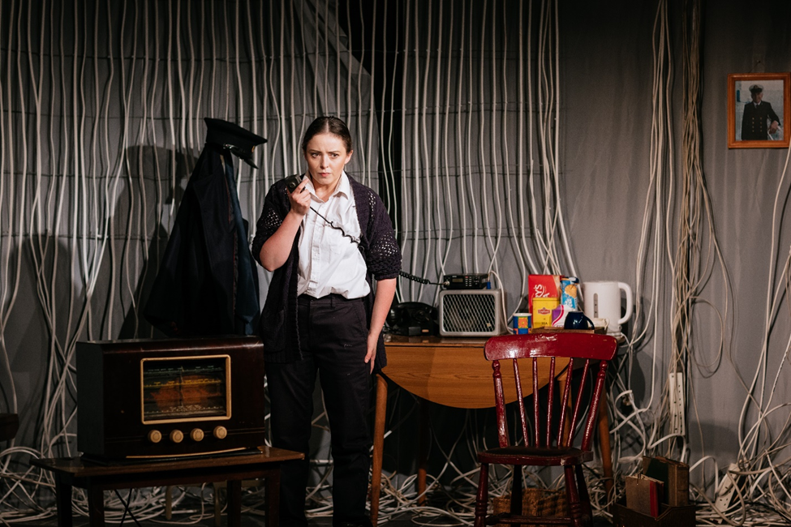
Eleanora Salter and the Monster from the Sea by Jane Madden, Dublin Fringe Festival 2021. Photo: Simon Lazewski

MARKETING & PR
WHAT’S THE DEAL WITH MARKETING AND PR?
Shows programmed at Dublin Fringe Festival will be included in the festival brochure, on fringefest.com, on social media and potentially in press releases and editorial. Dublin Fringe Festival is marketed as an overall entity, showing the breadth and quality of the programme. Individual shows will not feature in lead festival advertising, but a select edit of the programme may appear in e-newsletters, press materials and other promotional print and online materials. Inclusion in such campaigns is not guaranteed and depends heavily on the quality of promotional imagery, copy and video supplied by each company or artist, the nature of the project itself and festival marketing strategy. To give your project the best possible opportunity for inclusion, engage with the Marketing team early and conceive, produce, and deliver marketing material with as much lead time as possible.
Dublin Fringe Festival endeavours to promote every show, but we are not resourced to develop or implement individual marketing and PR plans for companies or artists. You will be expected to have your own marketing plan in place to promote your work. The marketing team will be able to advice on best practice, crafting strong marketing copy and eye-catching imagery.
Attendance at Fringe’s free marketing meetings is strongly advised, particularly if it is your first-time presenting work with the festival. The marketing team will be available to discuss your marketing plans throughout the summer. The marketing team will be able to advise on best practice, crafting striking copy, eye-catching imagery and how best to optimise digital media.

VOLUNTEERS & WILLING WORKERS
I’LL NEED SOMEONE TO WORK ON MY SHOW AS A DESIGNER/PRODUCER/DIRECTOR/TECHNICIAN ETC. CAN YOU HELP?
Yes! We have a database called the Willing Workers List that is available to companies and artists who have been programmed in the festival. The list is of people who want to work on Dublin Fringe Festival events in a backstage capacity - it doesn’t include performers. Fringe participants are welcome to contact them and all agreements are made directly between the artist and the Willing Worker. This list will be circulated to Programmed Artists in their Artist Guide shortly after being programmed.
I’LL NEED VOLUNTEERS. CAN YOU HELP?
Yes! We have a Volunteer Coordinator who recruits and schedules volunteers for the weeks of the festival. They are mainly scheduled for box office, front of house and production, but you can also contact the volunteer coordinator with specific requests. This needs to be done early as the scheduling needs to be done well in advance of the festival. Our Volunteer Coordinator will be in touch with all programmed artists in July 2023.

THANK YOU FOR READING THIS!
Phew! We know that’s a lot of information but reading this will greatly help you to make the best application possible. If you have any further questions about putting an event on in Dublin Fringe Festival you can contact the Artistic Projects Manager, bee@fringefest.com

